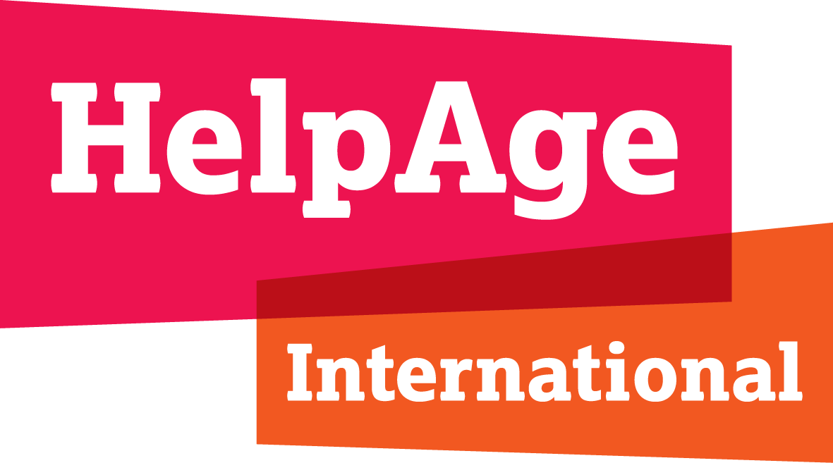

HelpAge International Submission on Social Protection and Social Security (including social protection floors)
10th Working Session of the Open-ended Working Group on Ageing, 2019

Introduction
Older people must be part of the growing discussion on their human rights. To this end, in November 2018 HelpAge International consulted 348 older women and 191 older men across 23 countries on the rights to be discussed at the 10th Session of the UN OEWG. This submission presents the issues they raised and uses their own words. Participants were self-selecting, so their responses are not a representative sample of older people.

Question 2: Availability - pensions
Over a third of participants in the consultation said they did not receive an old-age pension, whether contributory or non-contributory. This mirrors International Labour Organisation data that globally, 32 per cent of people over retirement age do not receive a pension. This constitutes a significant gap in protection of the right to social security.

Question 3: Availability – affordable healthcare and care and support services
Everyone in the consultation who said their pension was not enough for an adequate standard of living said they could not afford the health care, medication, rehabilitation, dental care or assistive devices they needed. This suggests they do not have access to social security and social protection schemes which guarantee them access to adequate and affordable healthcare, or to care and support services for independent living in older age.

‘Without an electric wheelchair, I am but a plant that breathes and is barely alive, always indoors.’ 78-year-old woman, Serbia

‘It [my pension] is not enough as I have to buy disposable napkins [diapers] because sometimes urine just drips out and my trousers become wet. I feel very embarrassed.’ 86-year-old-man, South Africa

Question 4: Adequacy
While some said they could get by, many older people on a pension in our consultation said they were unable to afford basic necessities to survive: food, water, clothing, housing, medical care and care and support.

It’s so little, it’s impossible to survive on it. 81-year-old man, Kenya

Two thirds of those who said their pension was not enough said they could not afford to buy adequate or nutritious food.

‘The [monthly] old-age pension only buys food for one week.’ 62-year-old woman, Rwanda

Just over half said they could not afford to pay regular bills such as water, heating, electricity, rent and school fees.

I can’t afford to pay the electricity and water bills as well as the rent.
66-year-old woman, Tanzania

Some said the low value of the pension payment kept them dependent on others, for example their spouses, children or other family members.

‘[My children] keep supporting me with money and buy groceries for me.’ 76-year-old man, Jordan

Participants also said they could not afford to socialise with their family and friends or visit relatives.

Our relatives invite us to weddings, anniversaries or other celebrations, but we refuse the invitations because we can’t go without a present and we don’t have clothes to wear for such occasions. 67-year-old man, Moldova

Pensions where the value of the payment is so low fail to fulfil the right to social security and social protection because they do not provide an adequate standard of living and prevent older people living dignified, autonomous and independent lives and fully participating in society.

International legal framework
The unique barriers older people face to their right to social security and social protection are not adequately covered under international human rights law. These recommendations on how the right to social security and social protection should be applied in older age are informed by older people’s experience as reported in this consultation.

Older people have the right to social protection and social security without discrimination based on age or any other grounds, so they can live dignified, autonomous and independent lives and fully participate in society.

The right includes social protection and social security measures, whether in cash or in kind, to ensure adequate income security, access to healthcare, medication and assistive devices, and access to care and support services for independent living in older age.

Non-discrimination and equality
- All older people should enjoy this right without discrimination on the basis of their age, gender, disability or any other grounds.
- Social protection and social security schemes should be designed so that they do not discriminate on the basis of age, gender, disability or any other grounds.

Accessibility
- All older people have the right to access social protection and social security schemes without discrimination.
- Older people have the right to access information on all aspects of social protection and social security schemes, including information on eligibility, entitlements and fees.
- Older people, including those without identity documentation, should have access to support with applying for social protection and social security measures without delay.
- Delivery mechanisms for social protection and social security measures must be adapted so they are accessible and affordable for all older people without discrimination.
- Social protection and social security measures must be portable and accessible to older people.

Availability
- Social protection and social security schemes must be in place to provide older people with social protection and social security measures relevant to the risks and contingencies they face, including in relation to care and support.

Adequacy
- Older people have the right to social protection and social security measures, whether in cash or in kind, of a high enough value and quality, and for a long enough duration of time for an adequate standard of living and to enable them to live dignified, autonomous, independent lives and fully participate in society.

Acceptability
- Older people have the right to social assistance and in-kind social protection and social security measures that are appropriate and acceptable for their needs and preferences.

Autonomy
- Older people have the right to mechanisms, including supported-decision-making processes, to exercise their right to autonomy and independence in relation to the use of income from social protection and social security schemes.

Accountability, remedies and redress
- Older people have the right to access accountability mechanisms that provide for complaints and appeals, and for remedies and redress when their right to social protection and social security is violated.

A full report of the consultation findings will be submitted to the OEWG in advance of the 10th Session. For further information contact Bridget Sleap, HelpAge International bsleap@helpage.org

Argentina, Cambodia, Denmark, Finland, Jordan, Kenya, Kyrgyzstan, Lesotho, Mauritius, Moldova, Mongolia, Myanmar, Nepal, Russian Federation, Rwanda, Serbia, Slovenia, South Africa, Sudan, Tajikistan, Tanzania, Ukraine, Zambia
. ILO, World Social Protection Report 2017–19: Universal social protection to achieve the Sustainable Development Goals, 2017, p.75

